Homework 15

Done by: Devdhar Kodiatar

24.1.2:

R value is chosen to be 10 kilo ohms.

24.2.1:

$\frac{1}{20000}=(PR3+1)$ × N × 12.5 ns

Therefore, $PR3=3999$

24.2.2 (a): OC1 waveform

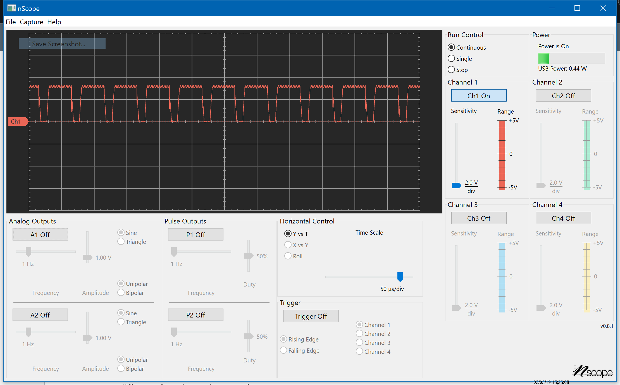

24.2.2 (b): Sensor voltage Vout

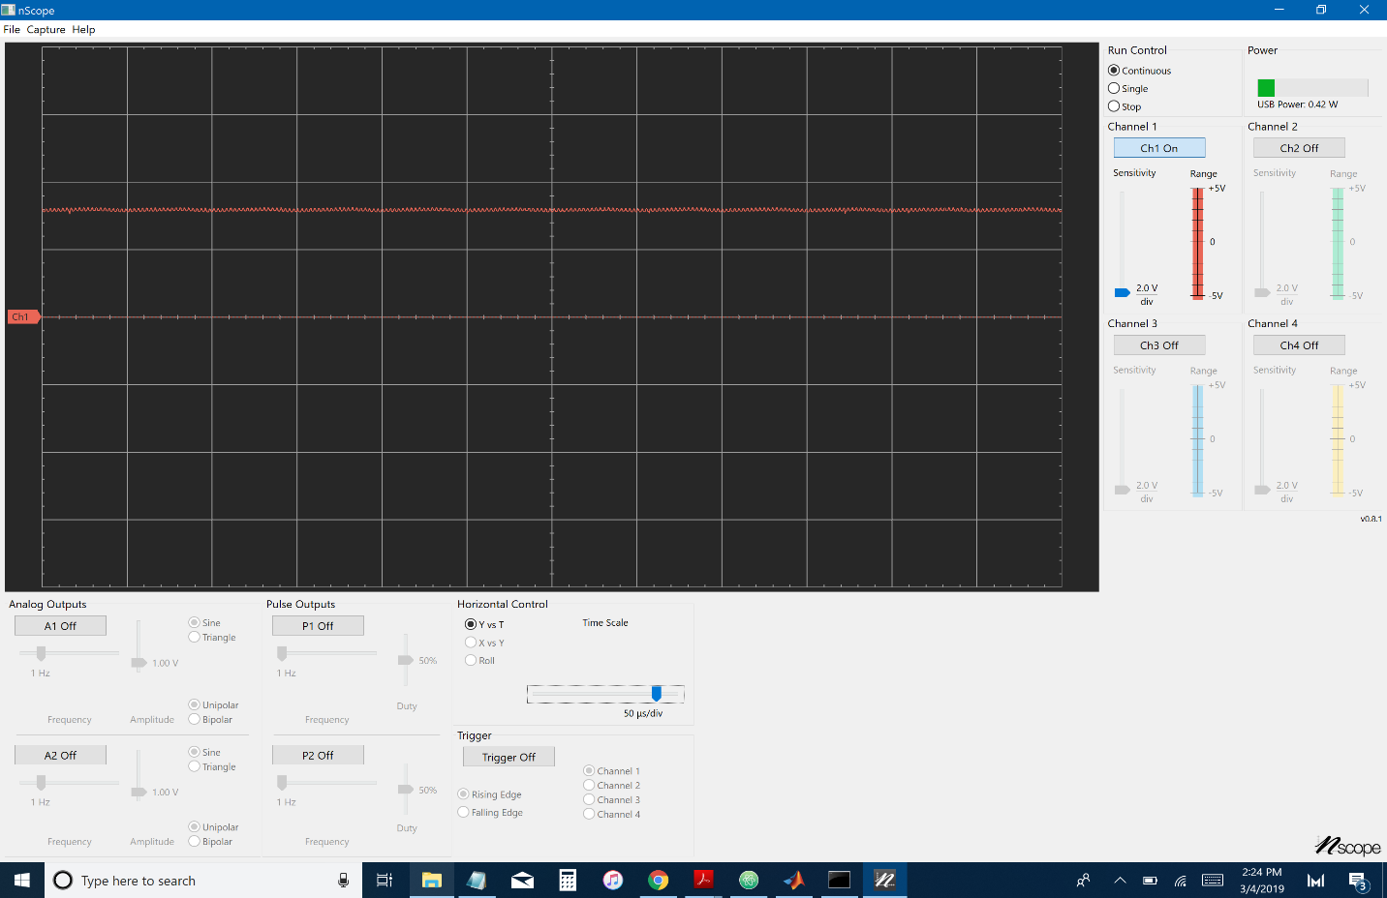

24.2.2 (c): Sensor voltage Vout (without 1µF capacitor)

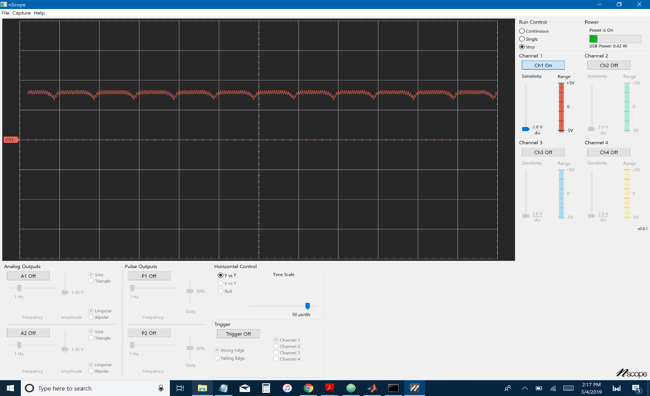

24.3.1: Sensor Voltage Vout with ISR

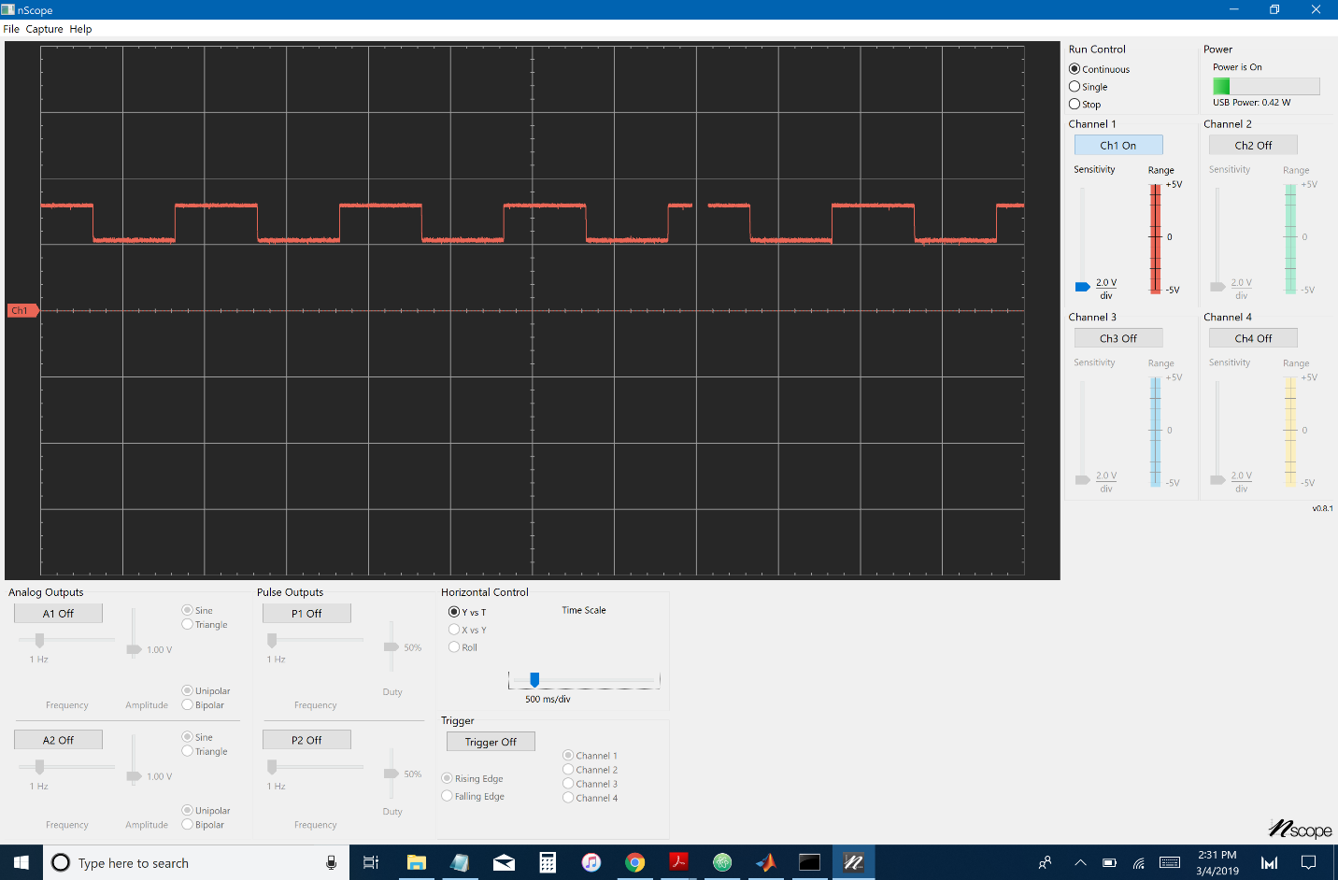

24.5: MATLAB communication with the PIC32

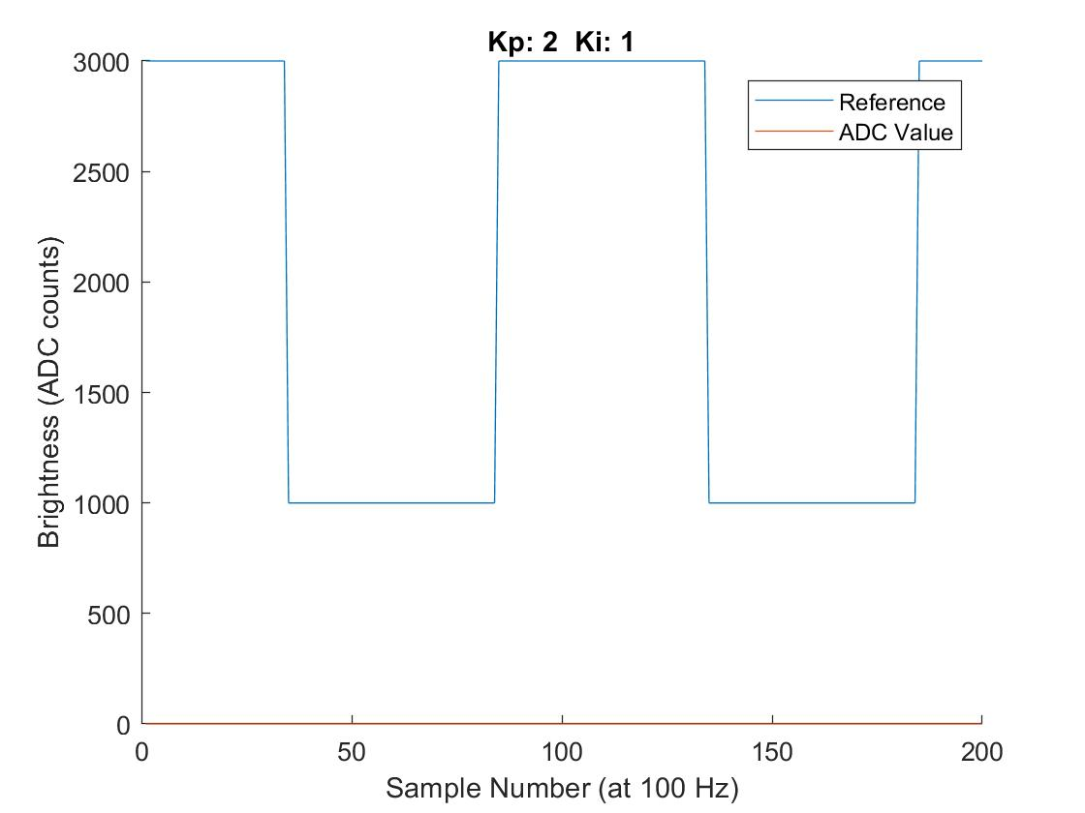

24.7: Reading the ADC value

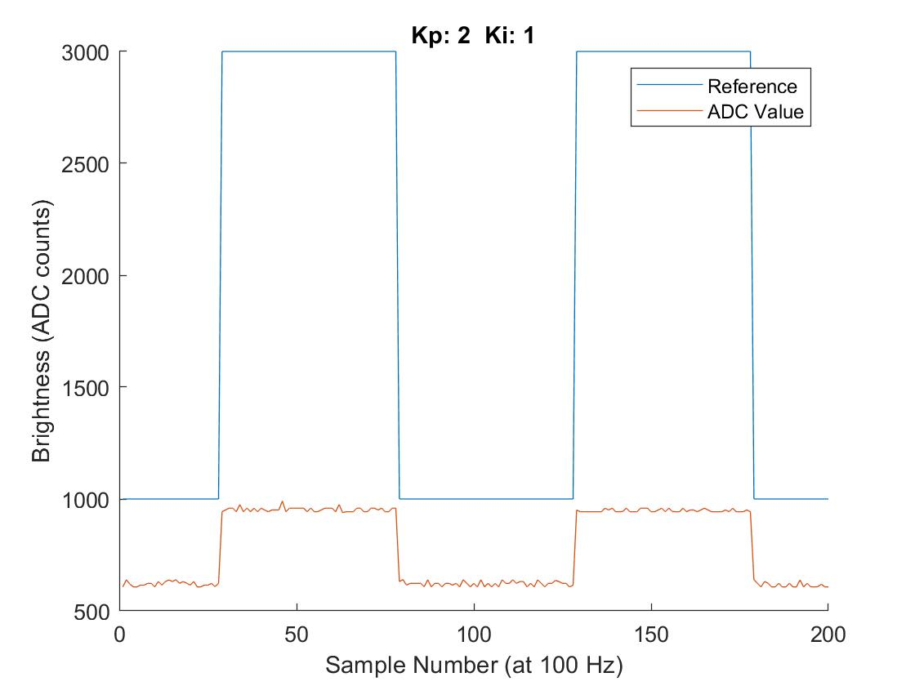

24.8: Normal tuned response

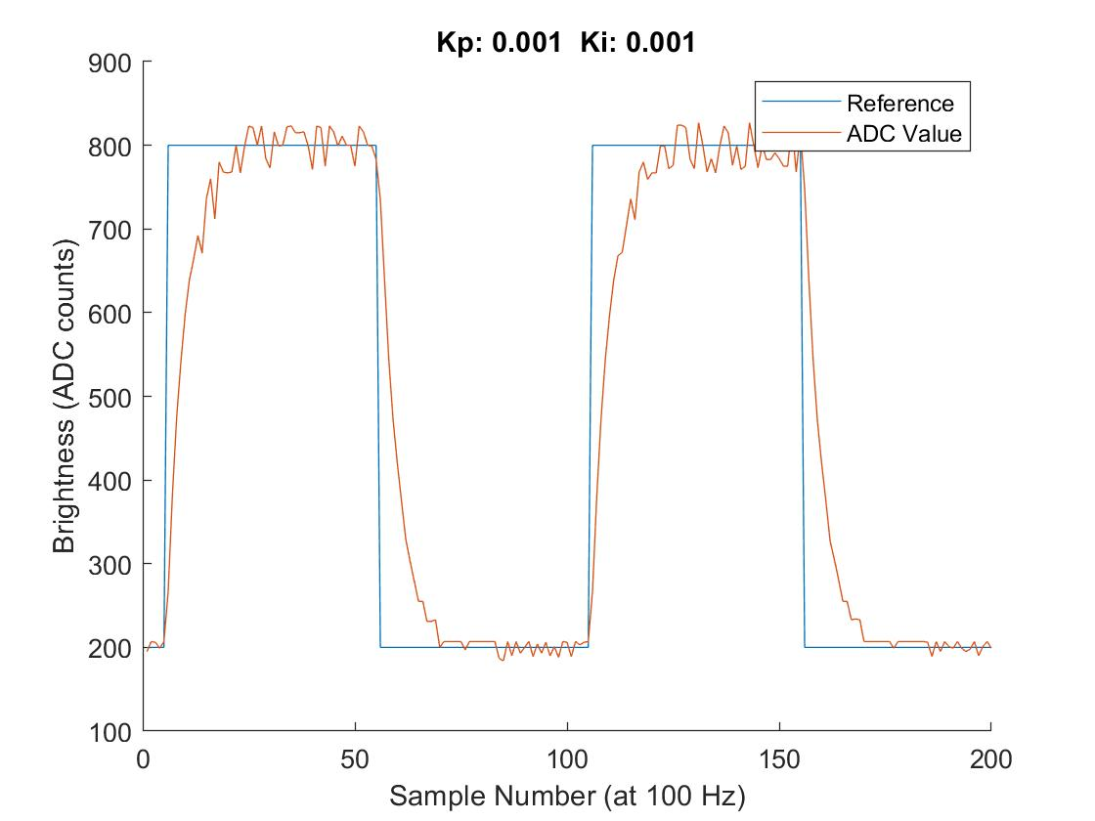

24.8: Best tuning

